**Internal movement challan**

**3 views:**

Admin view

Dashboard

Garph

Datalist1

Datalist2

Masters

Plot

Vessel

Customer

Cargo

Transporter

Movement

Challan generation(composed of 2 steps)

Create Challan

Print challan

At gate

Check out

Breakdown

At yard(destination)

Complete trip

Reports

Generated but nt gate outed challans

Gateouted vehicles yet to reach destination

Total completed trips

Edit challans

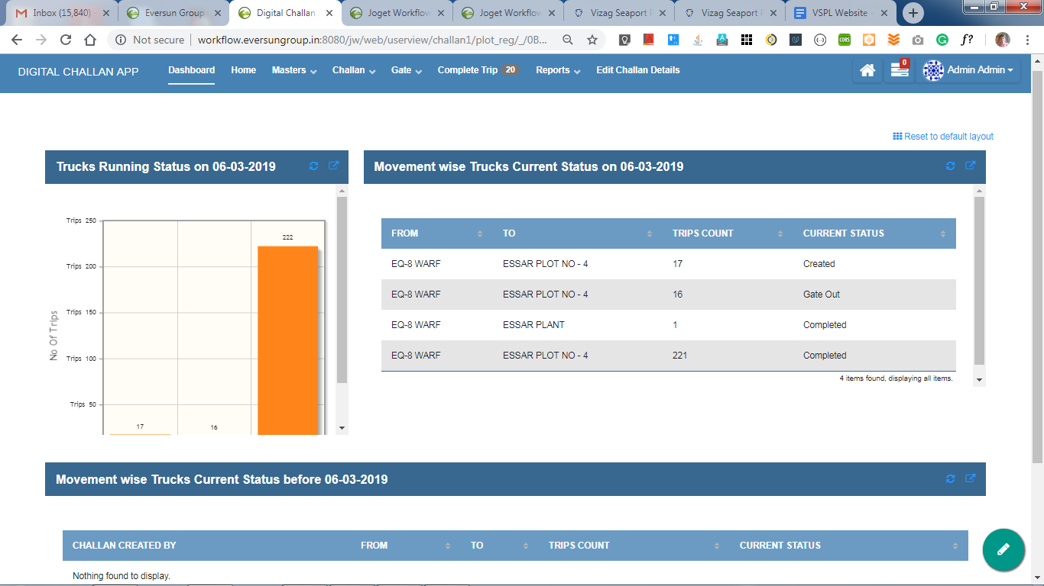

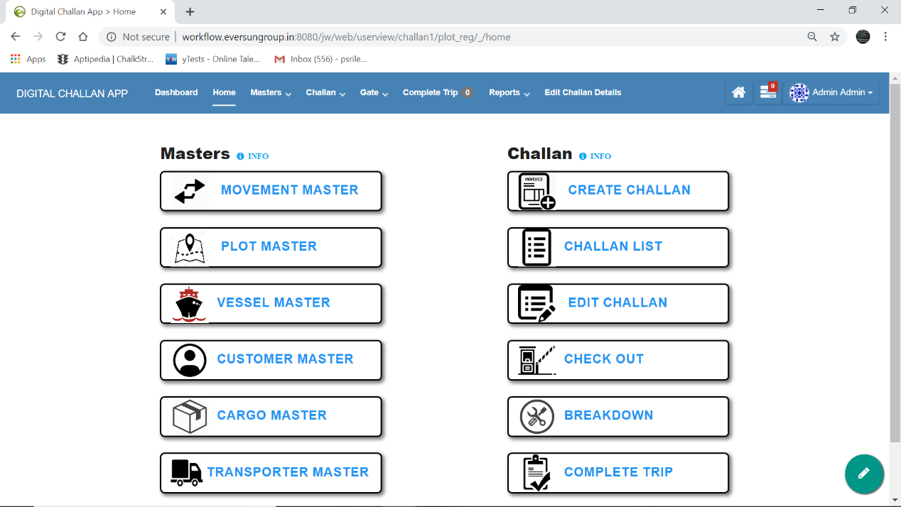

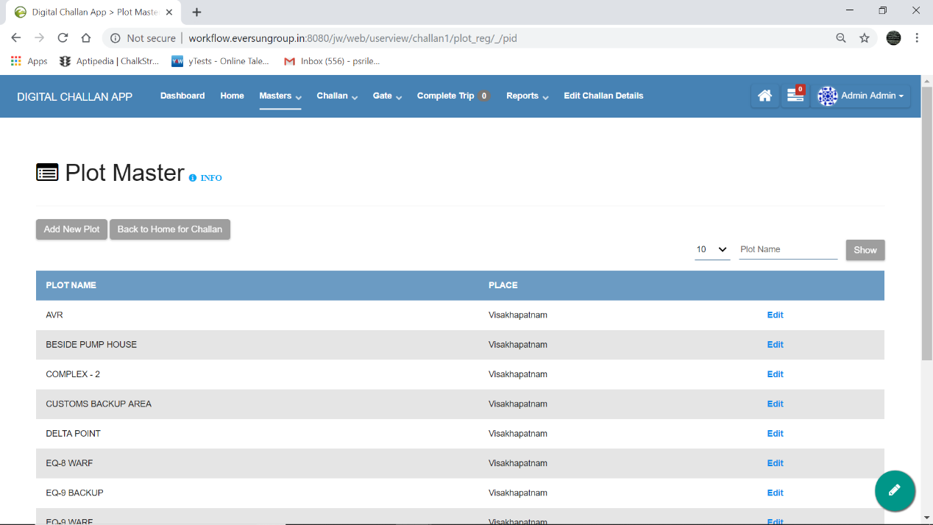

* **‘Add New Plot’ button** : It is provided at top left corner(marked by . red arow ). It can be used to add new plot details.
* **‘Back to Home for Challan’ button**: It is provided at top left corner (marked by . yellow arrow). It can be used to go back to Home Page.
* **INFO** : It is provided at top left corner(marked by . blue arrow). It gives a brief idea on how to use and traverse through the respective page.
* On the top right corner, fields (marked by . green colour oval shape) have been provided which can be used to filter the data provided over there. On filling either one of the fields provided there and hitting the ‘**show’** button, filters the data accordingly.
* **Edit** : A edit option has also been provided with respect to each plot data(marked by . dark yellow arrow). It allows the user to change the entered plot details if required.

**‘Add New Plot’ , ‘Back to home for Challan’** buttons are also provided at bottom left corner.

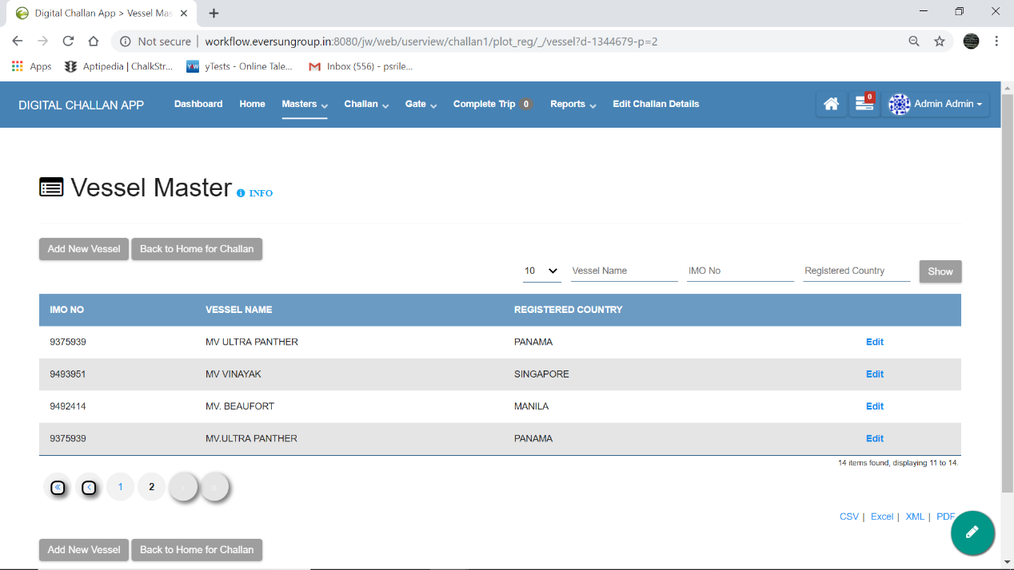

* **‘Add New Vessel’ button** : It is provided at top left corner(marked by . red arow ). It can be used to add new vessel details.
* **‘Back to Home for Challan’ button** : It is provided at top left corner(marked by . yellow arrow). It can be used to go back to Home Page.
* **INFO** : It is provided at top left corner(marked by . blue arrow). It gives a brief idea on how to use and traverse through the respective page.
* On the top right corner, fields (marked by . green colour oval shape) have been provided which can be used to filter the data provided over there. On filling either one of the fields provided there and hitting the ‘**show’** button, filters the data accordingly.
* **Edit** : A edit option has also been provided with respect to each vessel data(marked by . dark yellow arrow). It allows the user to change the entered Vessel details if required.

**‘Add New Vessel’ , ‘Back to home for Challan’** buttons are also provided at bottom left corner.

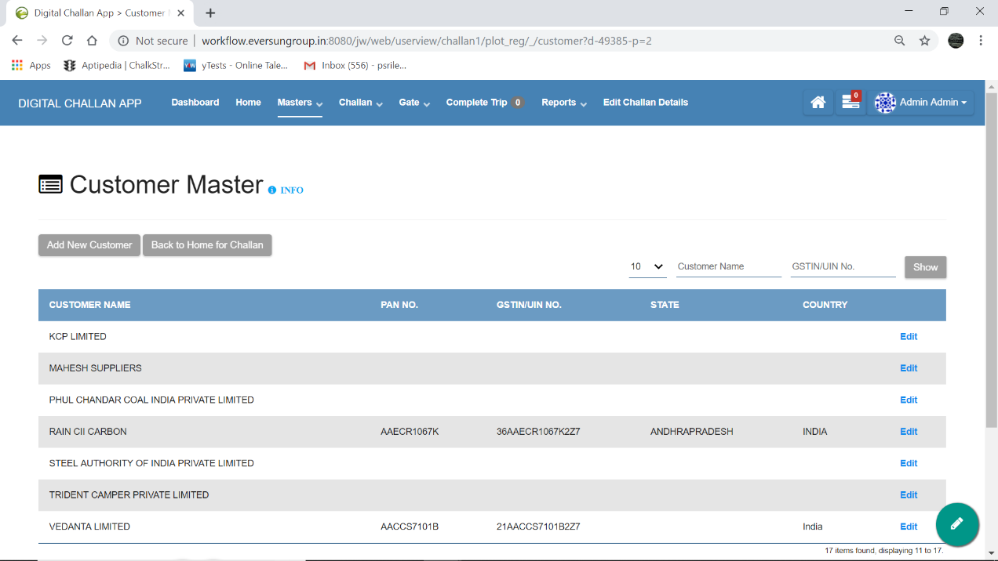

* **‘Add New Customer’ button** : It is provided at top left corner(marked by . red arow ). It can be used to add new customer details.
* **‘Back to Home for Challan’ button** : It is provided at top left corner(marked by . yellow arrow). It can be used to go back to Home Page.
* **INFO** : It is provided at top left corner(marked by . blue arrow). It gives a brief idea on how to use and traverse through the respective page.
* On the top right corner, fields (marked by . green colour oval shape) have been provided which can be used to filter the data provided over there. On filling either one of the fields provided there and hitting the ‘**show’** button, filters the data accordingly.
* **Edit** : A edit option has also been provided with respect to each customer data(marked by . dark yellow arrow). It allows the user to change the entered Customer details if required.

**‘Add New Customer’ , ‘Back to home for Challan’** buttons are also provided at bottom left corner.

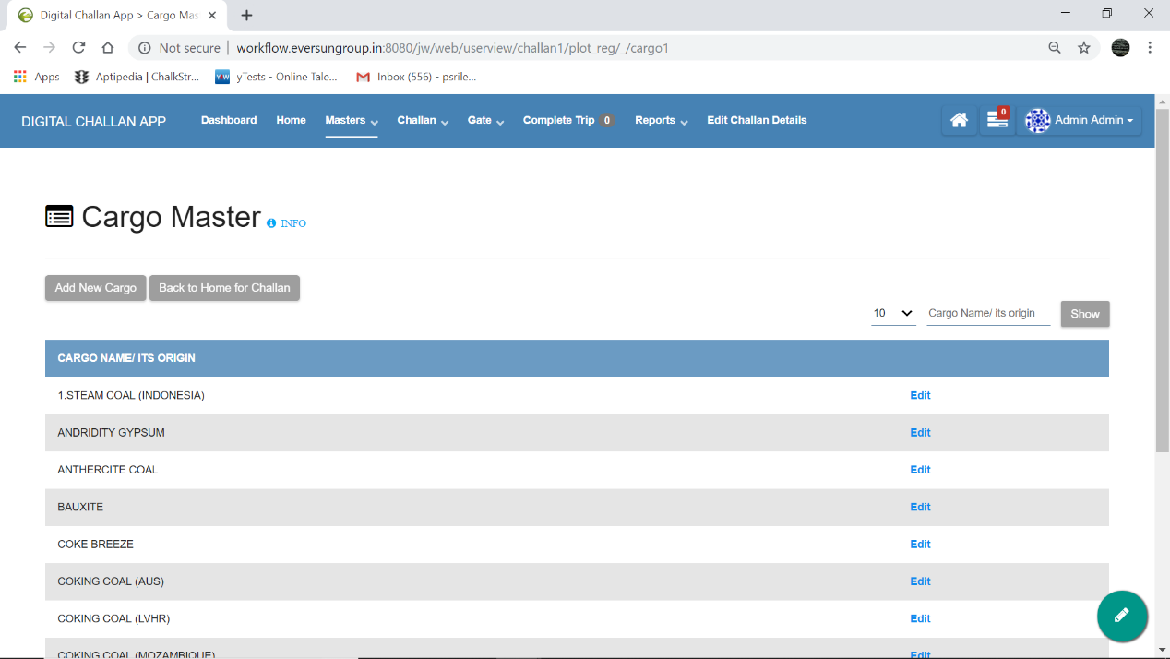

* **‘Add New Cargo’ button** : It is provided at top left corner(marked by . red arow ). It can be used to add new cargo details.
* **‘Back to Home for Challan’ button** : It is provided at top left corner(marked by . yellow arrow). It can be used to go back to Home Page.
* **INFO** : It is provided at top left corner(marked by . blue arrow). It gives a brief idea on how to use and traverse through the respective page.
* On the top right corner, fields (marked by . green colour oval shape) have been provided which can be used to filter the data provided over there. On filling either one of the fields provided there and hitting the ‘**show’** button, filters the data accordingly.
* **Edit** : A edit option has also been provided with respect to each cargo data(marked by . dark yellow arrow). It allows the user to change the entered Cargo details if required.

**‘Add New Cargo’, ‘Back to home for Challan’** buttons are also provided at bottom left corner.

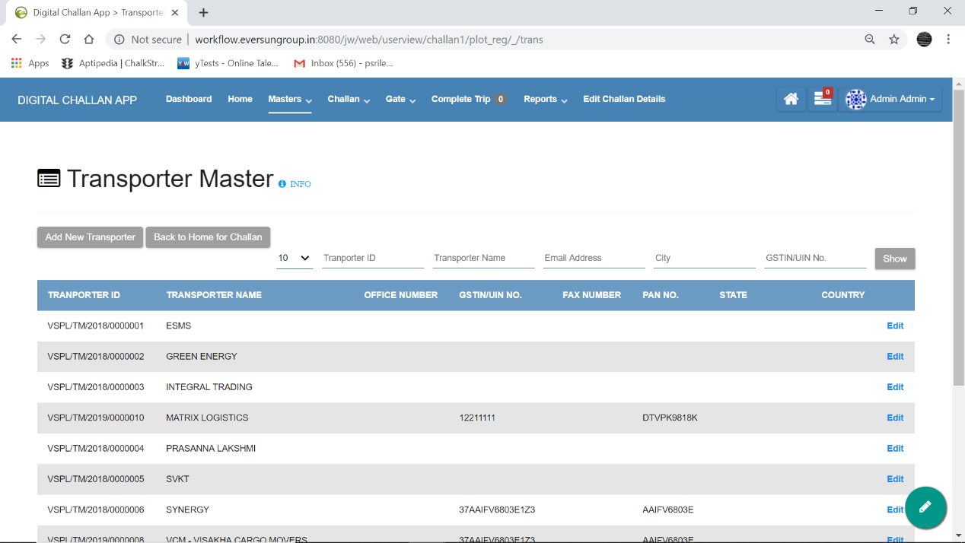

* **‘Add New Transporter’ button** : It is provided at top left corner(marked by . red arow ). It can be used to add new Transporter details.
* **‘Back to Home for Challan’ button** : It is provided at top left corner(marked by . yellow arrow). It can be used to go back to Home Page.
* **INFO** : It is provided at top left corner(marked by . blue arrow). It gives a brief idea on how to use and traverse through the respective page.
* On the top right corner, fields (marked by . green colour oval shape) have been provided which can be used to filter the data provided over there. On filling either one of the fields provided there and hitting the ‘**show’** button, filters the data accordingly.
* **Edit** : A edit option has also been provided with respect to each Transporter data(marked by . dark yellow arrow). It allows the user to change the entered Transporter details if required.

**‘Add New Transporter , ‘Back to home for Challan’** buttons are also provided at bottom left corner.

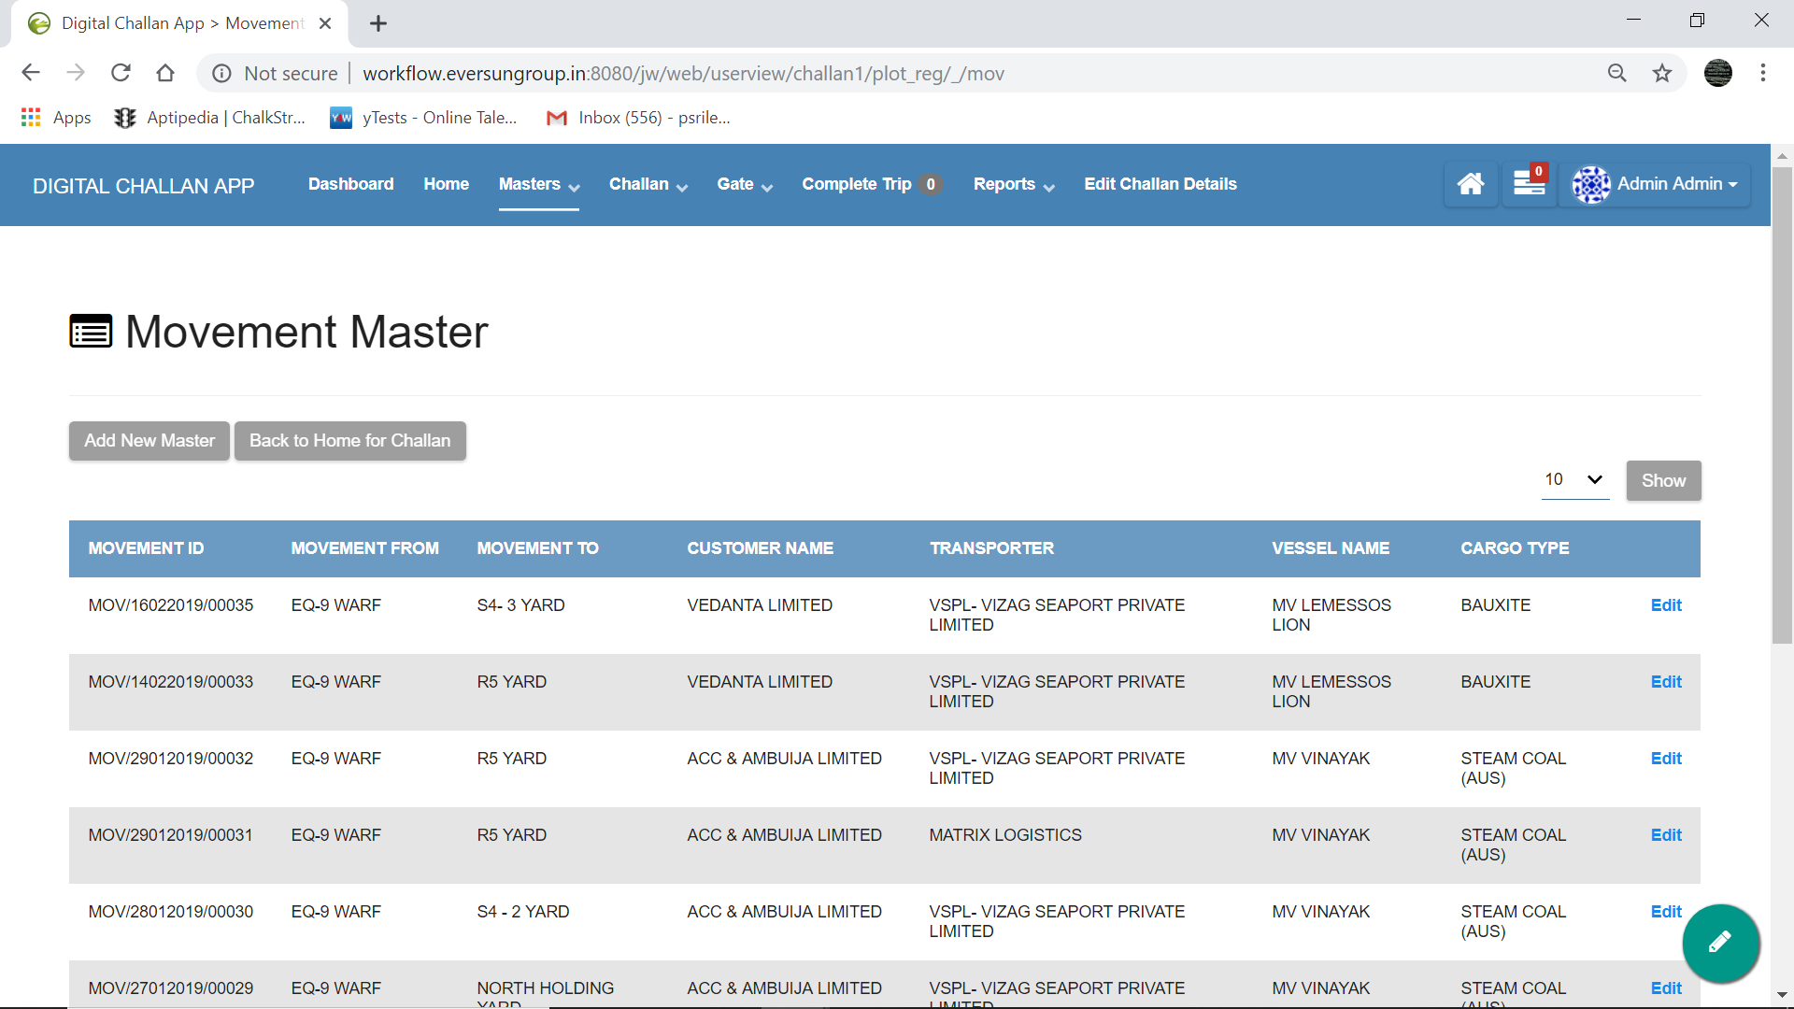

* **‘Add New Movement’ button** : It is provided at top left corner(marked by . red arow ). It can be used to add new Movement details.
* **‘Back to Home for Challan’ button** : It is provided at top left corner(marked by . yellow arrow). It can be used to go back to Home Page.
* On the top right corner, fields (marked by . green colour oval shape) have been provided which can be used to filter the data provided over there. On filling either one of the fields provided there and hitting the ‘**show’** button, filters the data accordingly.
* **Edit** : A edit option has also been provided with respect to each Movement data(marked by . dark yellow arrow). It allows the user to change the entered Movement details if required.

**‘Add New Movement’ , ‘Back to home for Challan’** buttons are also provided at bottom left corner.

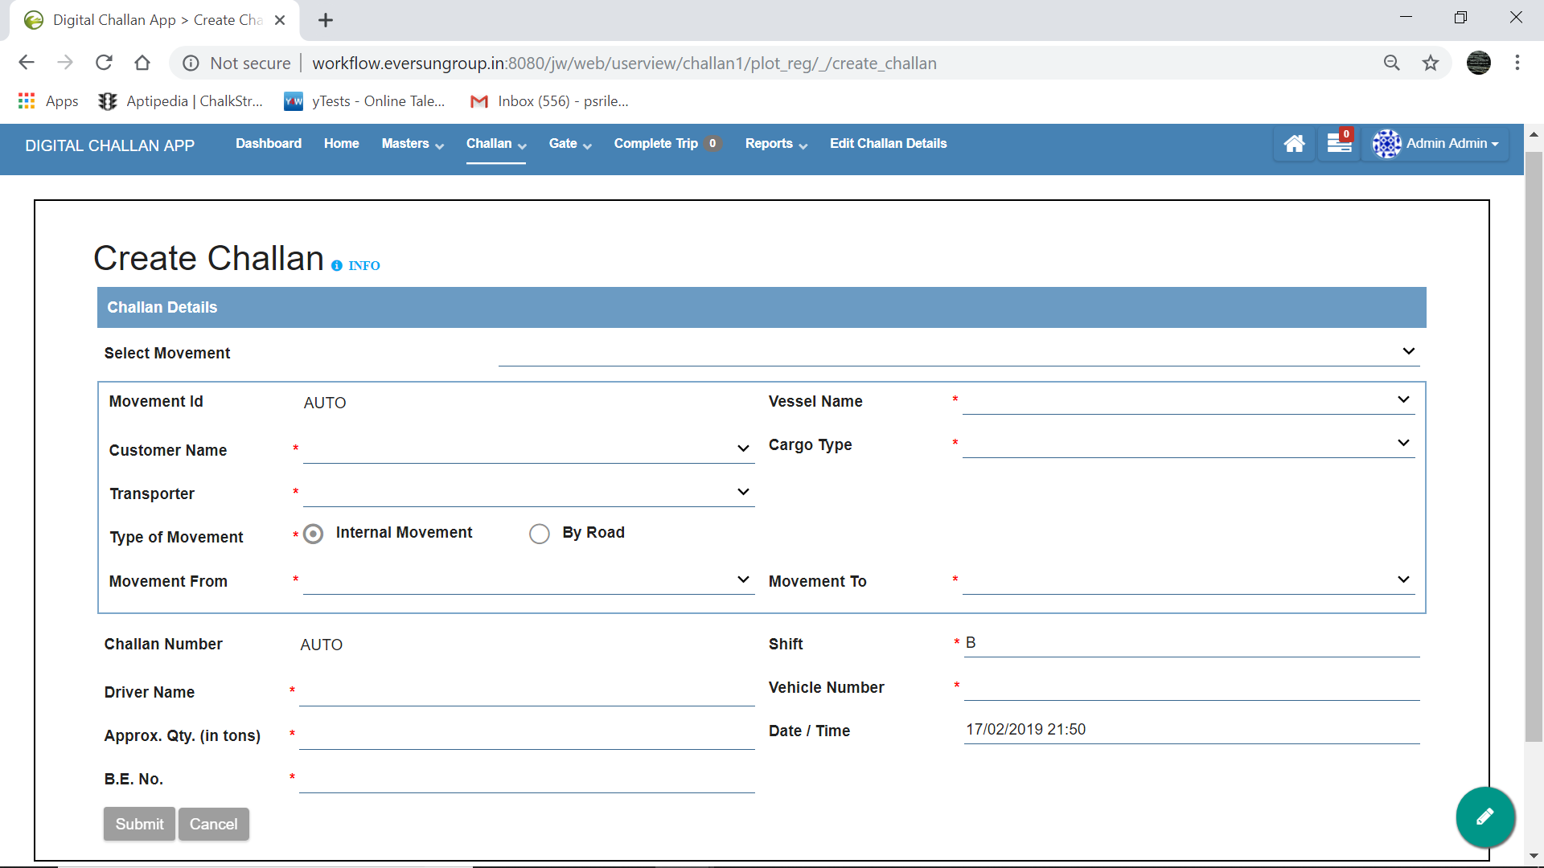

**NAVIGATION: Home >> Create Challan** (or) in header, **Challan >> Create Challan**

* **INFO** : It is provided at top left corner(marked by . blue arrow). It gives a brief idea on how to use and traverse through the respective page.
* Inorder to create a Challan all the required details have to be filled and then submitted.

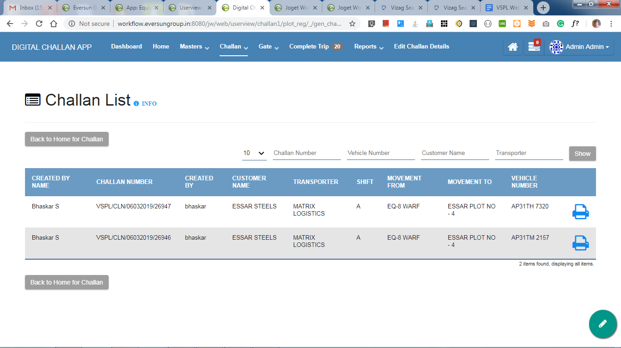

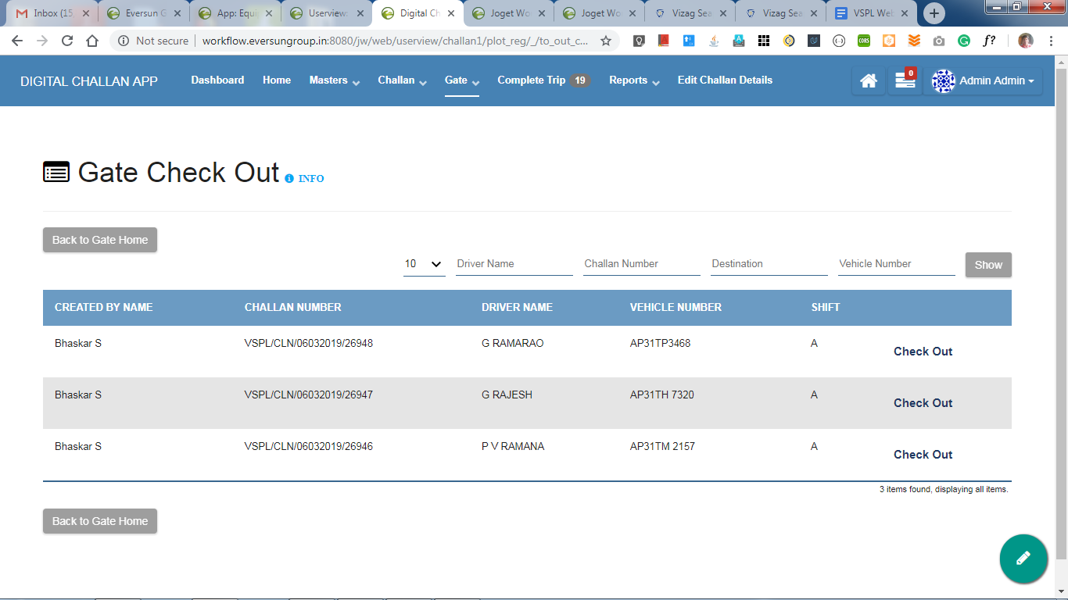 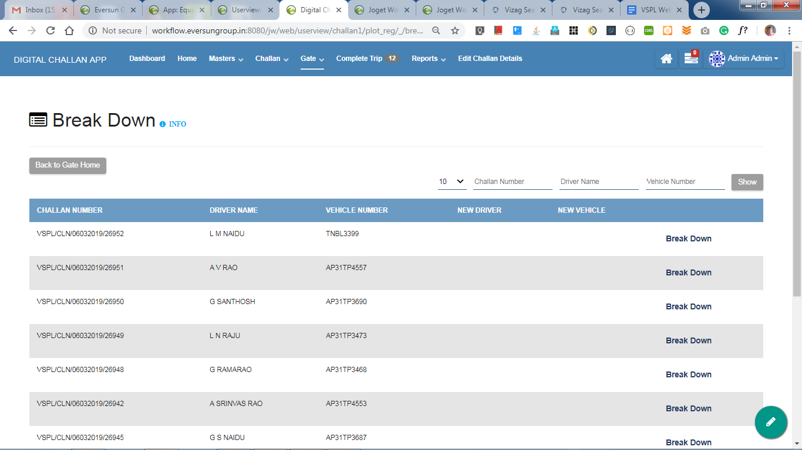

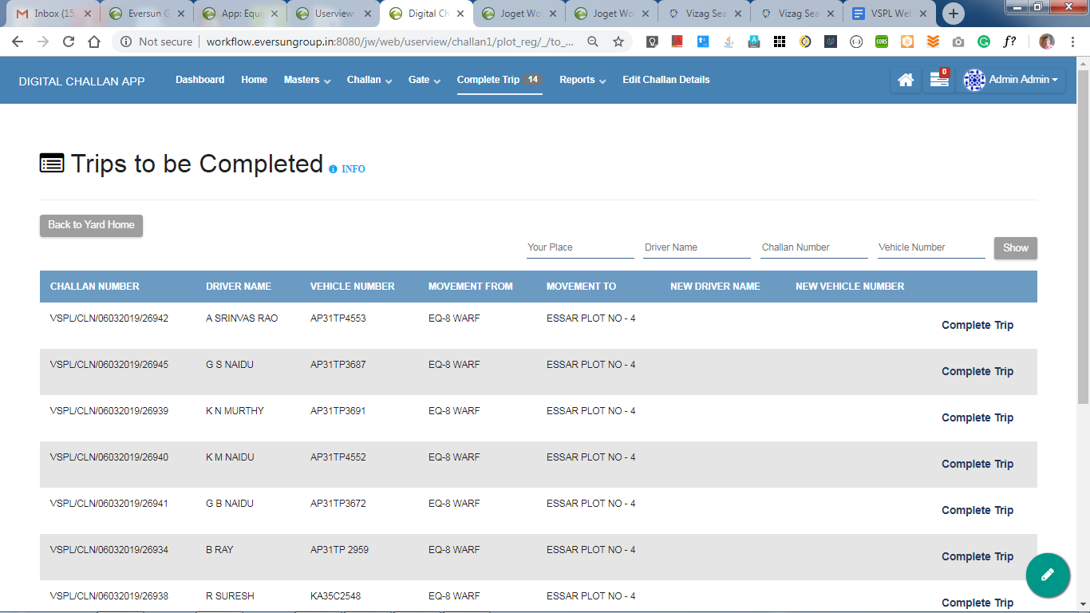Report-generated challan pic

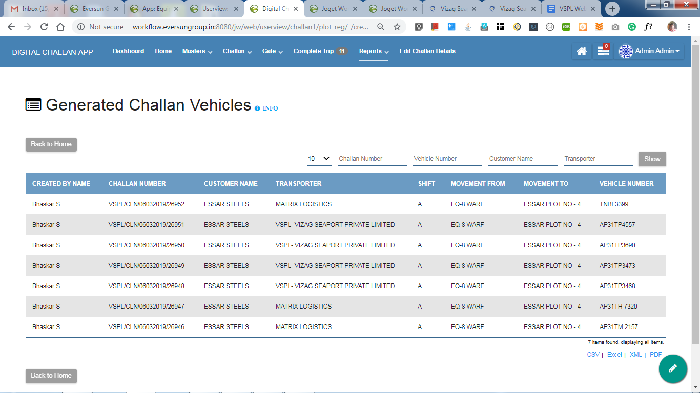

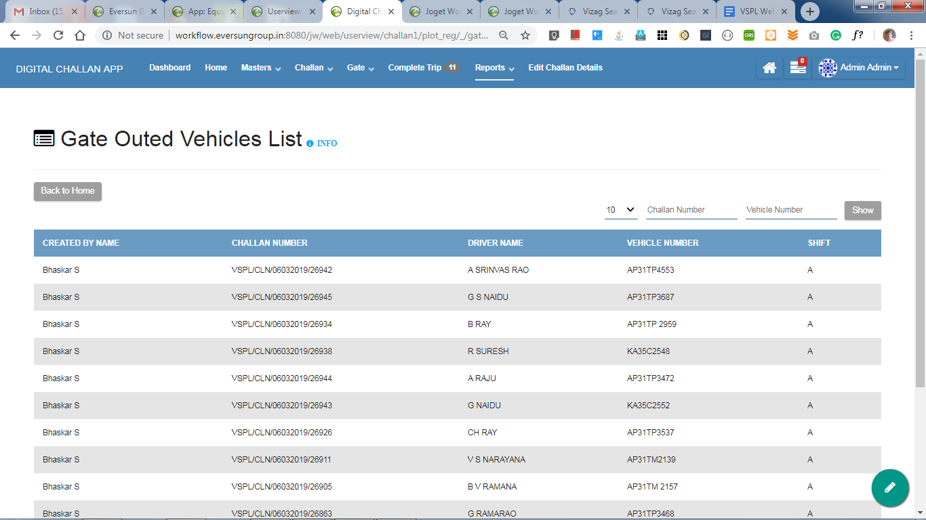

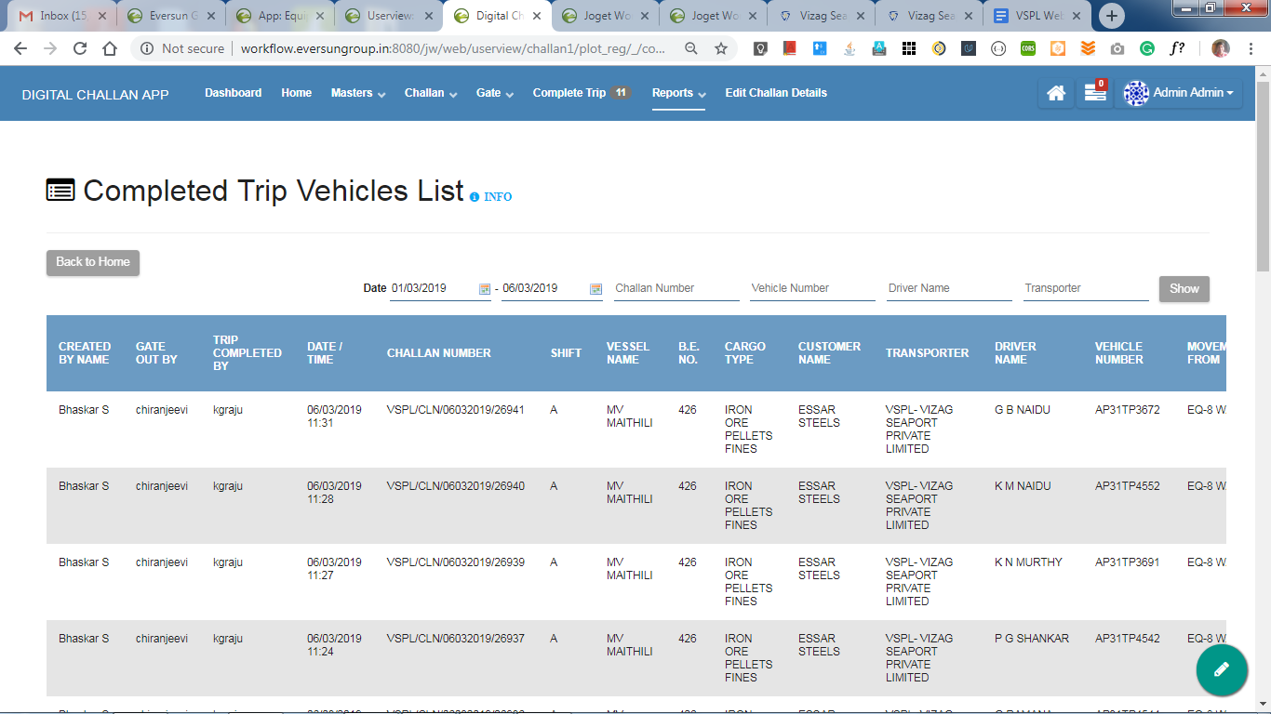

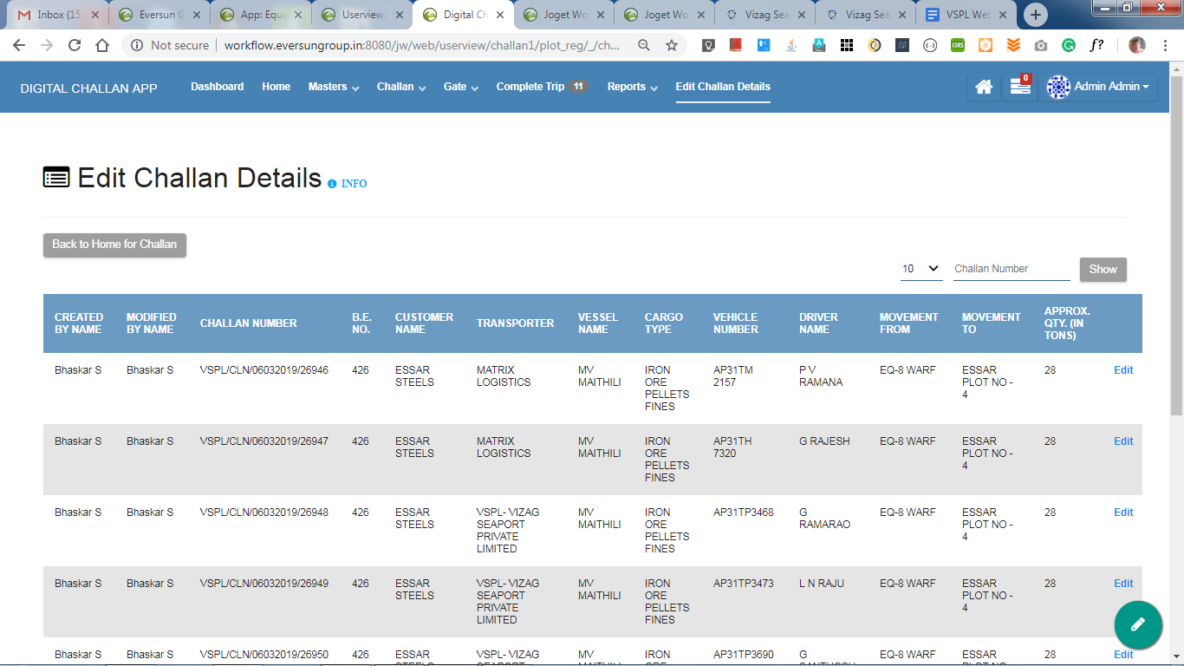

User view

Generation point

Masters

Plot

Vessel

Customer

Cargo

Transporter

Movement

Challan generation(composed of 2 steps)

Create Challan

Print challan

Gate

Check out

Breakdown

Yard(destination)

Complete trip

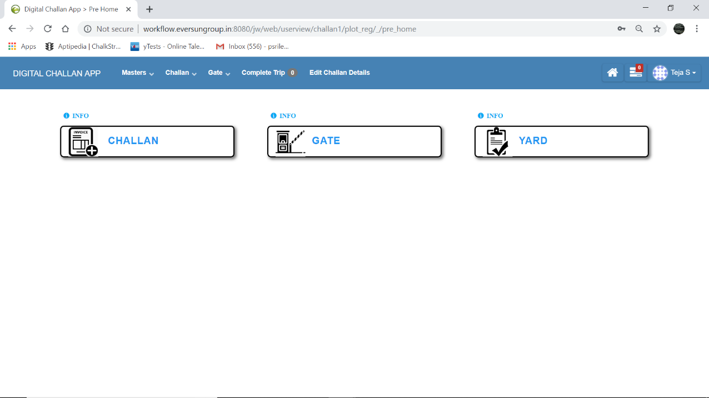

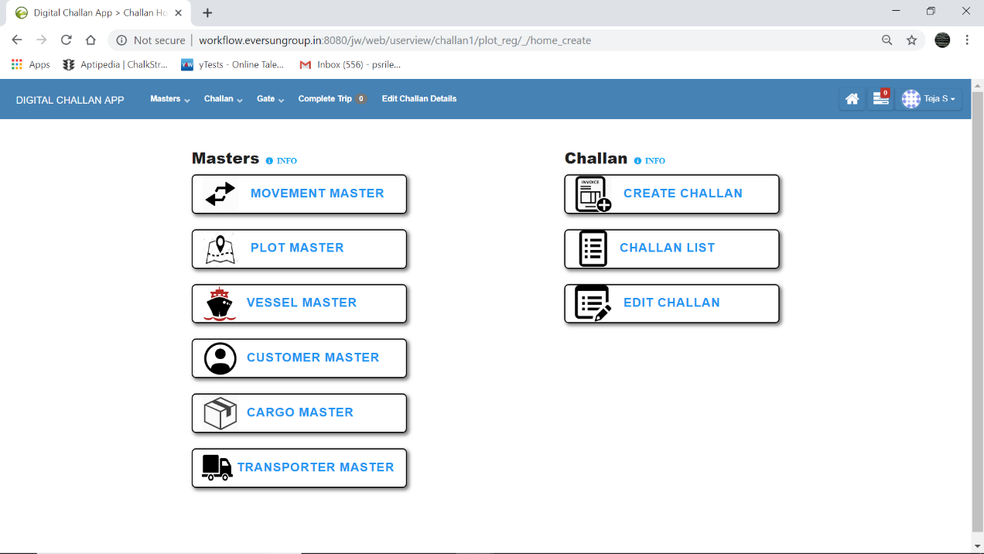

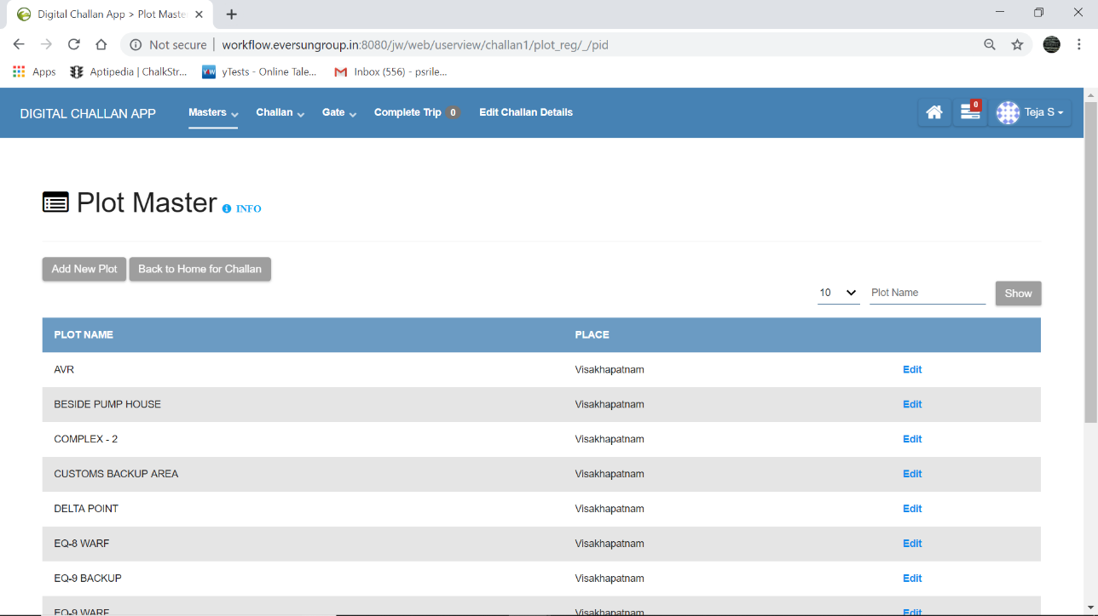

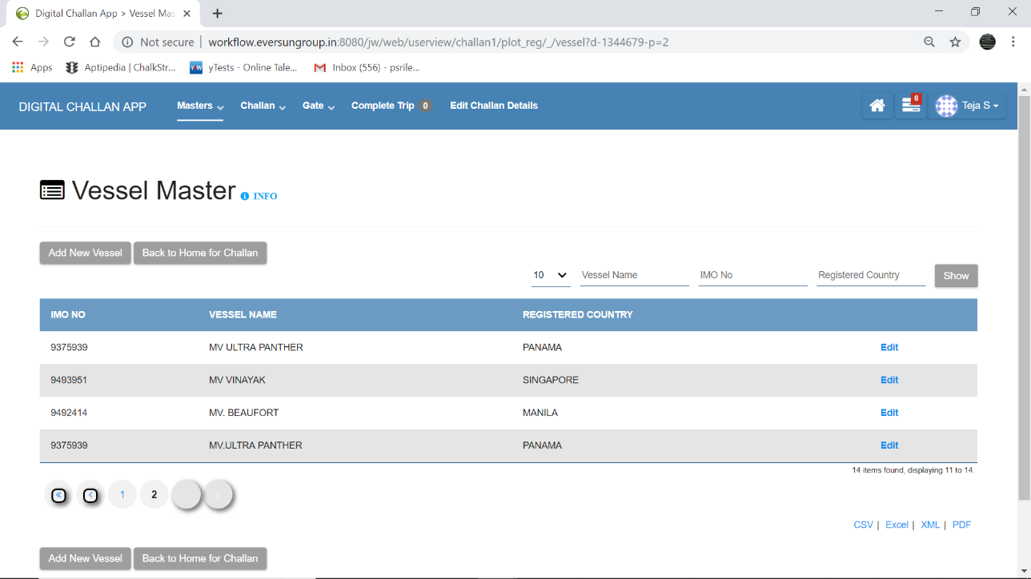

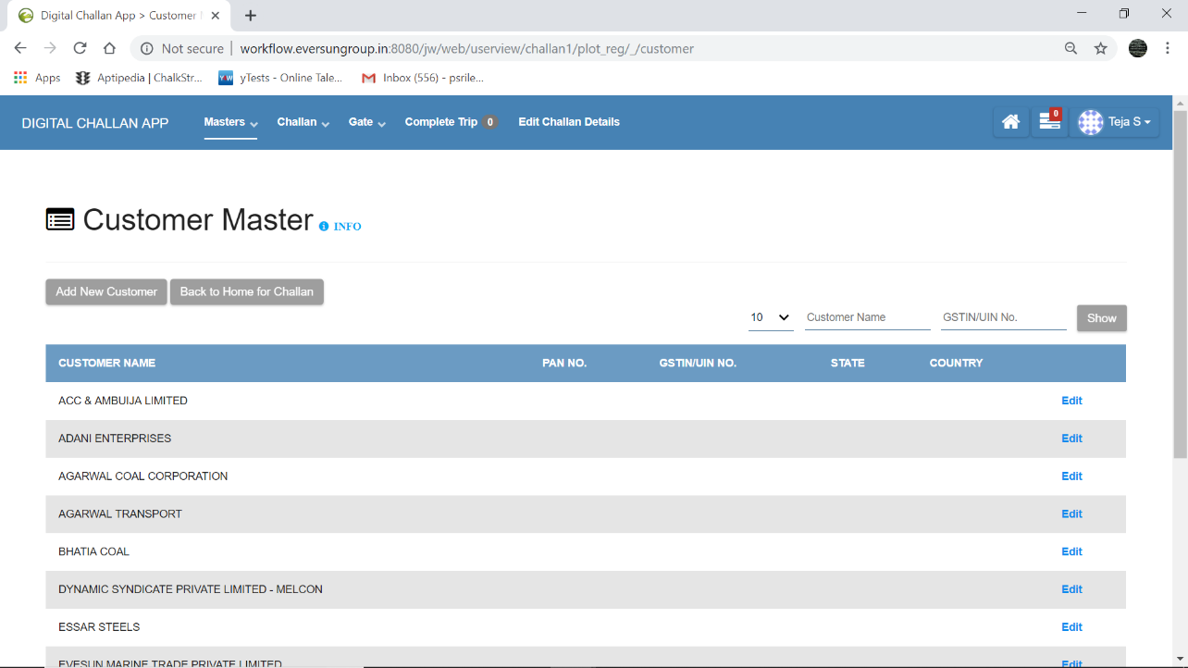

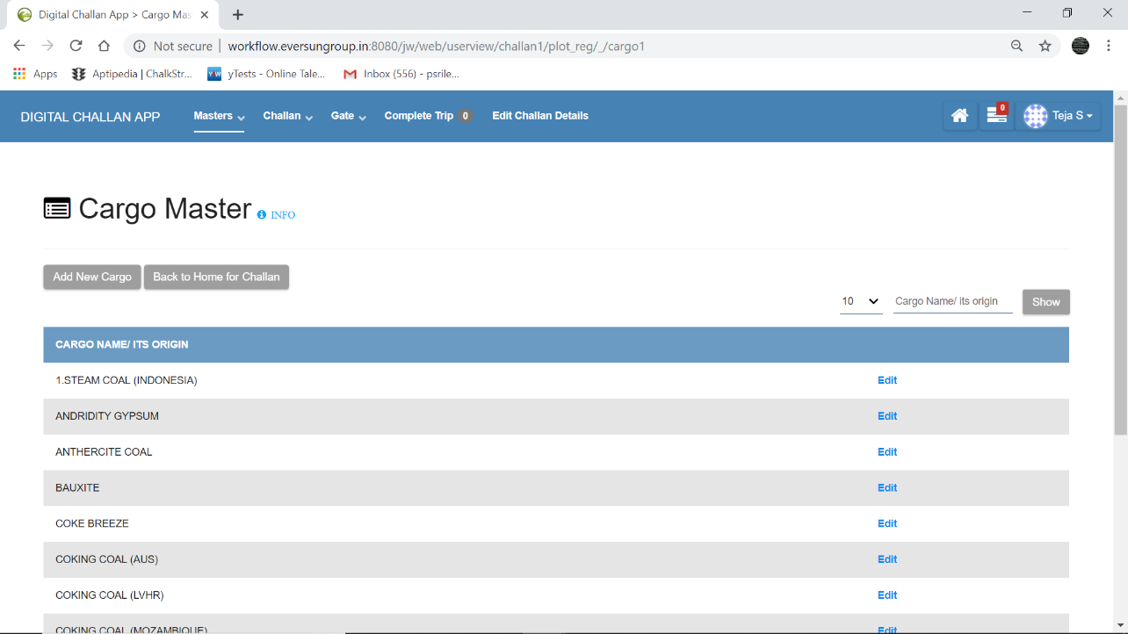

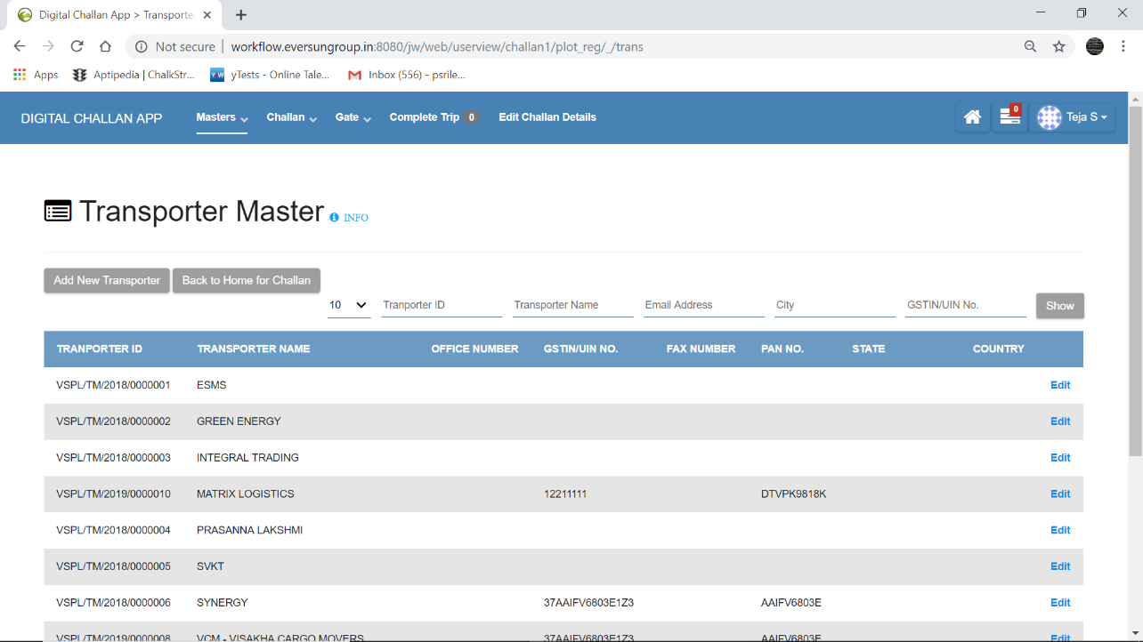

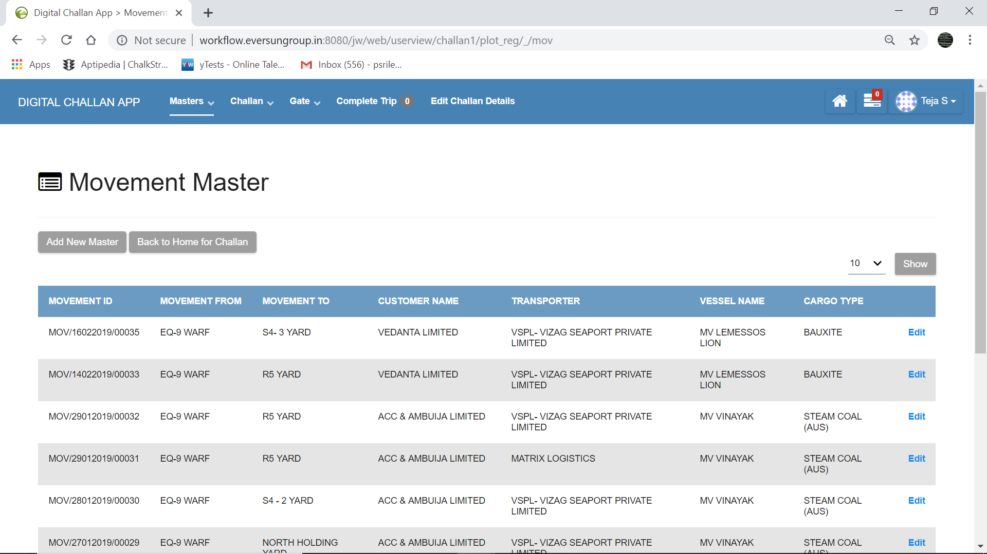

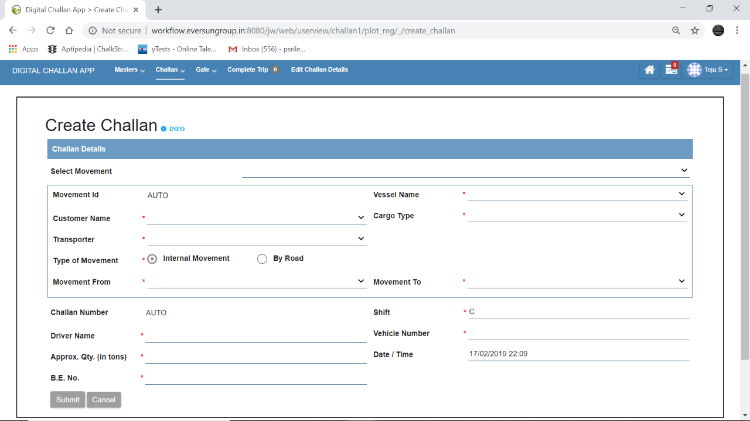

Print challan pics

Gate out pic

Break down pic

Complete trip pic

Edit challan pic

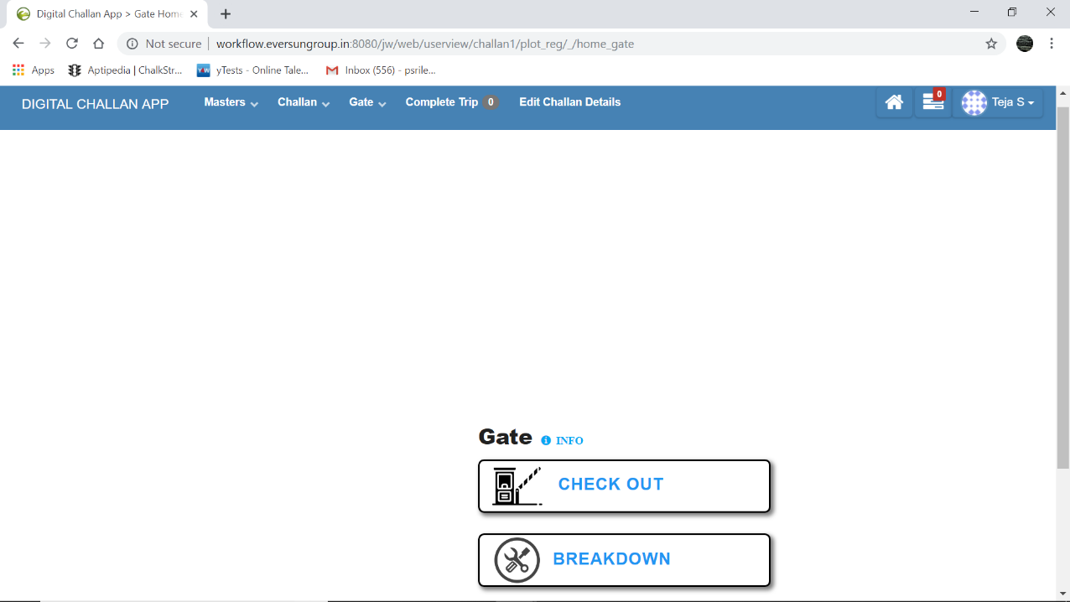

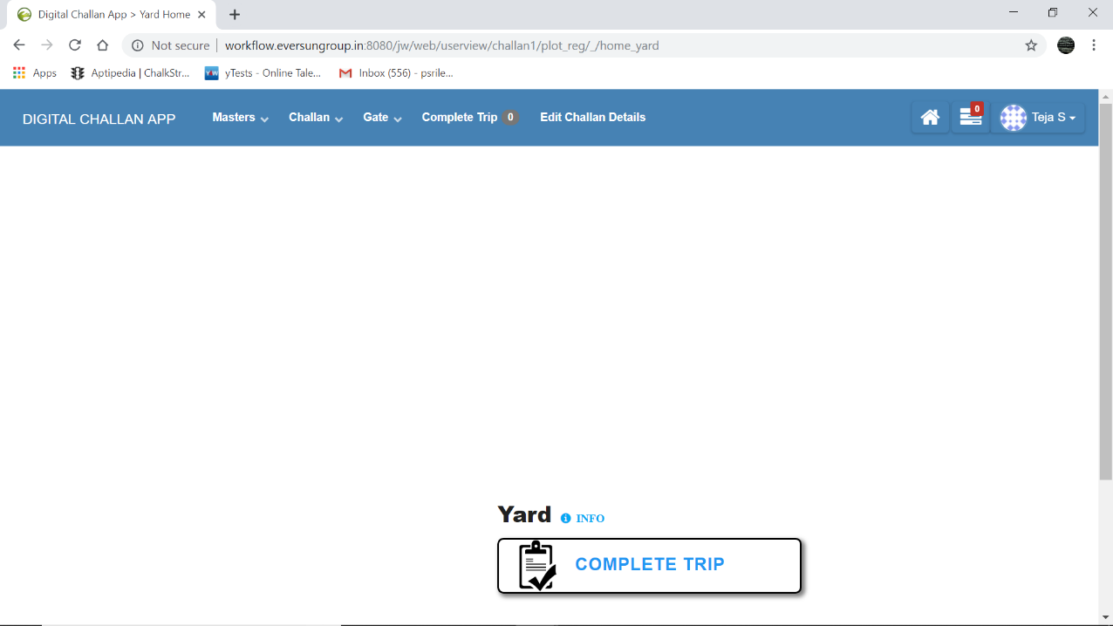

Analyser/Observer

Dashboard

Garph

Datalist1

Datalist2

Reports

Generated but nt gate outed challans

Gateouted vehicles yet to reach destination

Total completed trips

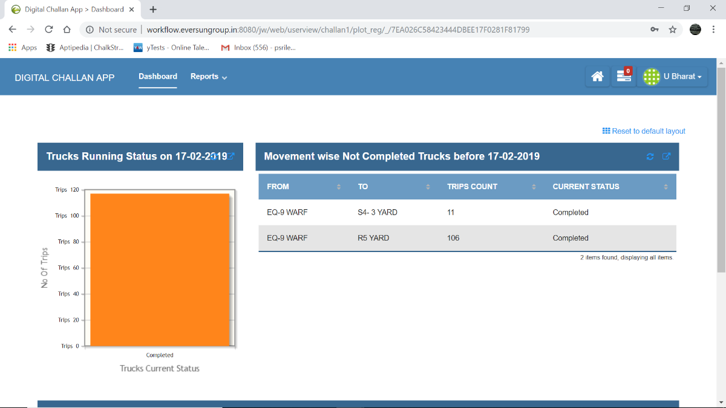

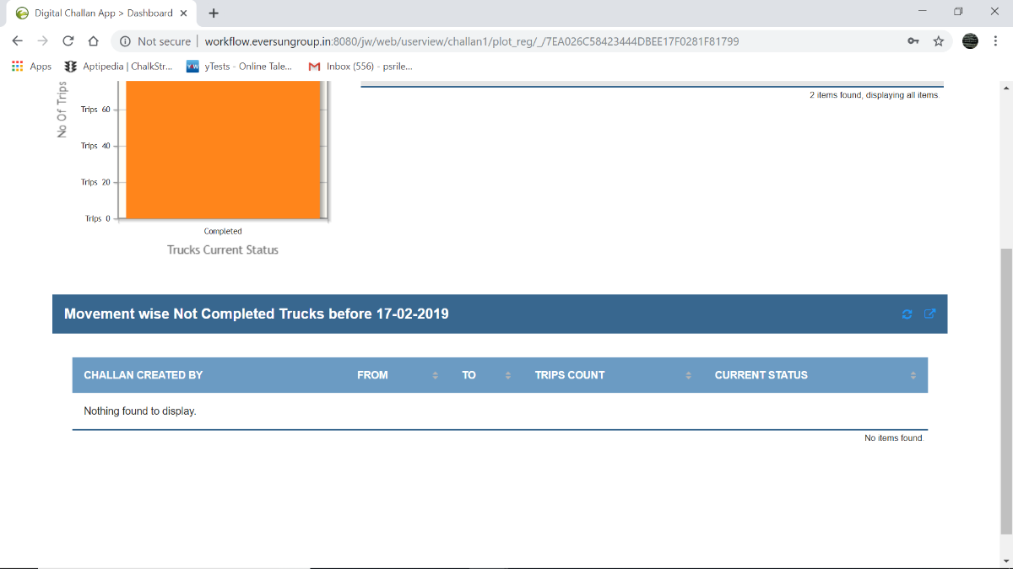

Reports

Generated but nt gate outed challans pics

Gateouted vehicles yet to reach destination pics

